Newsletter issue: 2 Date: December 2020

Introduction

With the recent government announcements of further lockdown and tougher tiered systems coming into force, I recognise that this is a difficult time for many, and I want to first thank you all for your ongoing commitment to working to support our most vulnerable children, young people and adults. We all have a part to play in keeping ourselves and others safe, Helping those who need our care and Jesus’ love is especially important during this pandemic; more people feel lonely and anxious; more families struggle with unemployment, hardship and poverty; and more abuse is hidden in people’s homes.
Within our denomination there is a strong interest in learning how to place safeguarding at the centre of the Church’s mission; this became quite clear as a result of last October’s online event promoting the URC’s five-year strategic plan. This quarter’s newsletter will highlight the importance of awareness in recognising the different forms of abuse. also It also starts including news covering all countries where we have URC churches.
You can also read about the first safeguarding webinar which will take place in 2021 and focus on the psychological impact of COVID-19. There will also be an update about the implementation of the safeguarding training framework — the withdrawal of the training framework at Mission Council does not call into question the plan’s approach, instead more time is needed to consult with more people, and make use of this time as an opportunity to improve the efficacy of our safeguarding training standards across the denomination.
As always, we love to hear your thoughts and comments so do keep them coming in to us. Email us at safeguarding@urc.org.uk, liaise with your Synod Safeguarding Officer or engage with us on social media @SafeURC. As we approach Christmas and enter the Advent season, may the Lord’s blessings, peace and joy always be with you.

Ioannis Athanasiou
URC Safeguarding Adviser and Secretary to the Safeguarding Advisory Group

Since March 2020, Childline has seen an 11% in the requests for counselling sessions about online sexual abuse.

Online Safeguarding Symposium launches Strategic Plan

We would like to thank everyone who attended the Symposium on 9th November 2020. It was humbling to see so many people come together to learn more about the Safeguarding Strategic Plan and to share their experiences of safeguarding from across the denomination. We want to thank everyone who took part in the event especially Carla, Shelley, John, and Ioannis, who shared so much wisdom with us. We also appreciate the time that you gave to complete the surveys and your feedback has been listened to and acted upon.

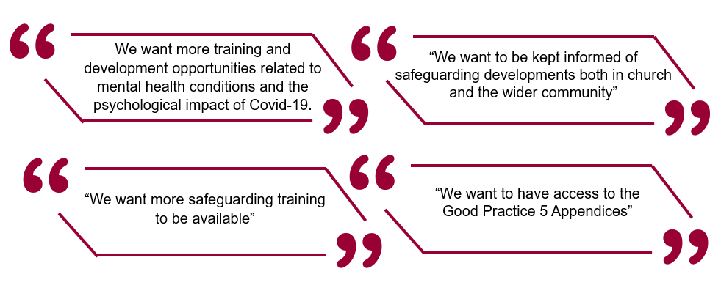
You said
We did

A Mental Health first aid webinar has been arranged for 2021. It will be the first of a series of webinars and it will focus on the impact of the Covid-19 pandemic on mental health and offer useful ways to manage this.

We have created this quarterly newsletter to keep you up to date with safeguarding developments. We are working closely with the Communications Team to ensure that the URC website has up-to-date information that is easily accessible. We also have a Twitter account where you can keep abreast of relevant safeguarding news and information. You can follow us @SafeURC.

Synod Safeguarding Officers, with support from Penny McGee, the safeguarding training coordinator for the denomination, are working hard to be able to deliver safeguarding training to anyone who needs it and you should get in touch with them to find out when the next training course is.

The team at Church House have been working hard to deliver the final appendices. All appendices that do not need the approval of Mission Council are now in the process of being made available.

Join the URC’s Mental Health and Wellbeing Webinar

Following on from the success of the Safeguarding Symposium, the URC are offering a Mental Health and Wellbeing Webinar which will build knowledge of common mental health concerns, develop skills to support people through crisis and recognise the importance of having self-care strategies in place.

Topic areas will include:
• Recognising common mental health conditions.
• The impact of trauma on mental health and wellbeing.
• Alcohol, drug, and behavioural addictions.
• Recognising neglect and grooming behaviour.
• Supporting people through crises.
• Self-Care: faith and spirituality, self-compassion, and psychological tools.

The webinar will be held online over the course of two afternoons to ensure that there is enough time to cover the topics in sufficient detail as well as to ensure that there is enough time for participants to ask questions.

To book your place, please email safeguarding@urc.org.uk including your name, Synod and role. Please ensure that if you register for this event, you are able to attend both sessions. Spaces are limited and this training will be very popular so please get in touch with us sooner rather than later.

When: Friday 19th March and Friday 26th March
Time: 1pm – 4:30pm
Where: Online – You will receive joining instructions after you have registered your interest.

Many thanks to Belinda Nielsen, Synod Safeguarding Officer for Thames North and Southern Synods, for her efforts to secure this wonderful opportunity for us.
Thirtyone:eight has published the latest episode of their safeguarding podcast where they talk with author Cerys Morgan, who describes her journey of surviving abuse in a church context. You can find the link here

The Safer Internet Day 2021 will be celebrated on 9th February 2021. To help educators to deliver practical and impactful activities for Safer Internet Day, the UK Safer Internet Centre have created a range of free resources, including; films, lesson plans, assemblies, quick activities to help children and young people aged 3-18 learn about online safety issues. There are resources for 3-7 year olds, 7-11 year olds, 11-14 year olds and 14-18 year olds as well as resources for parents and carers.
Please click here to access the resources!

Thirtyone:eight have publicly pledged to change the way that survivors of abuse in church contexts are treated. Click here to join their pledge!

Safeguarding Training Framework

Safeguarding training is a crucial aspect of keeping everyone safe at church and is vital in our journey to prevent and respond to abuse in all forms. For these reasons, a safeguarding training framework has been created to be used across the denomination to support consistency of knowledge and practice.

Mission Council generally welcomed the framework for safeguarding training for the whole church. The basic principles of the framework in terms of a three-tier approach to safeguarding training has not been questioned, and the necessity for mandatory training were not contested. The framework was withdrawn with a view that, with further work and consultation, it would be ready to be resubmitted in March 2021.

Basic safeguarding training will continue to be delivered across the denomination in alignment with the decision made at Mission Council in March 2021. Please get in touch with your Synod Safeguarding Officer if you want to book training or to find out more about training.

If you want to provide feedback about the development and finalisation of the framework (which is planned to be passed in the next Mission Council), please write to Penny McGee at safeguarding@urc.org.uk by 18 December. You can find a link to the Mission Council paper here.

Synod Safeguarding Training

To adapt with the changing government guidance and to facilitate learning whilst gathering in large groups is still not permitted, the safeguarding team have adapted the physical training module into a virtual format held via Zoom, which has been condensed to suit this platform.
The following dates are available to book on to:
Tuesday 26th January 2021 at 7pm (BASIC)
Friday 5th February 2021 at 6pm (INTERMEDIATE*)
Monday 15th February 2021 at 10am (BASIC)
Tuesday 2nd March 2021 at 7pm (BASIC)
Tuesday 23rd March 2021 at 12pm (BASIC)
Tuesday 6th April 2021 at 6.30pm (INTERMEDIATE*)
*Attendance at the Intermediate training requires completion of the BASIC course first.
To book on to this training, please email their name, church and preferred date to safeguarding@urcsouthern.org.uk or safeguarding@urcthamesnorth.org.uk

URC Support during Covid-19

Despite our best efforts, over the summer months the pandemic continues. We now face a long winter of restrictions ahead of us; different people will react differently to periods of crisis — there is no “right” way to feel as we find ourselves traversing this current time of difficulty. Whether you need emotional or practical support during this time, you can visit the URC website to find out more about support and resources in your region.
To get the latest Government guidance for safely reopening places of worship in your area, please click on one of the links below.
England Wales Scotland

Safeguarding Adults Week 2020

Ensuring the safety and wellbeing of adults is a crucial aspect of safeguarding, which was marked by the Safeguarding Adults Week in November. The pandemic has seen a drastic increase in adult safeguarding risks especially those impacted by domestic and financial abuse. The Ann Craft Trust has developed a range of links and resources to use if you are interested in learning more about safeguarding adults, these can be found here.

URC Commits to being an Anti-Racist Church

Mission Council have unanimously passed a resolution committing the URC to being an “anti-racist” church. Speaking at Mission Council, Sarah Lane Cawte (Convenor of Mission Committee) drew attention to the difference between being non-racist (which is passive and accepts the status quo) and anti-racist (which actively challenges racism). You can find a link to the Mission Council paper here.

Church of England to announce independent safeguarding body
Dr Jonathan Gibbs, lead bishop on safeguarding at the Church of England, has confirmed that independent trustees will hold the National Safeguarding Team to account. An independent panel will also be set up to approve support packages for survivors of abuse. The House of Bishops has unanimously endorsed a motion to accept the investigation report from the Independent Inquiry into Child Sexual Abuse and “unreservedly apologise” to those impacted for the harm done by the Church. The House has also committed itself to “urgently implementing” the Inquiry’s recommendations. You can read the full story here.
The Children and Youth team have produced some excellent, editable, and accessible PDF posters to be displayed in local churches. The posters should be displayed alongside Appendix B and are an accessible way of communicating the same message. They can be found here.
A special thank you to Lorraine Webb, Children’s and Youth Work Programme Officer, for her hard work on these.

NSPCC Resources to support keeping children safe in out of school settings

The NSPCC Learning hub has created a webpage to highlight the new Department for Education’s (DfE) guidance on keeping children safe in out-of-school settings and best safeguarding practices in England. A cross-sector group supported the DfE in developing the non-statutory guidance for providers of community activities, after-school clubs, tuition, faith and other out-of-school settings in England. The NSPCC Child Protection in Sport Unit (CPSU) has created content outlining what the guidance means for sports settings. You can read the full news story here or visit the CPSU site to use the resources.

Be part of the Scottish consultation on Child Protection procedures

The Scottish Government are consulting on a revised version of the National guidance for child protection to ensure that it is consistent with the legislative and policy framework and current practice developments. The deadline for responses is 17 January 2021. Read the consultation and get involved here.

Join the Welsh Government’s fight against harmful sexual behaviour

The Welsh Government has published guidance for education settings on how to prevent and respond to peer sexual abuse, exploitation, and harmful sexual behaviour, including digital abuse and exploitation taking place both inside and out of the settings. The guidance sets out the continuum of behaviours which constitute peer sexual abuse, exploitation, and harmful sexual behaviour and includes: the duties and responsibilities of education settings; a whole school approach to preventing and responding to peer sexual abuse; and an example school safety plan.

