August 2022
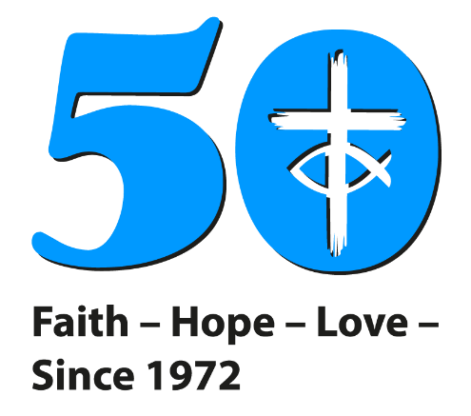
SAFEGUARDING
NEWSLETTER

INTRODUCTION
Welcome to the first Newsletter from the New Safeguarding Team at Church House. These newsletters will be produced quarterly and provide an update on all Safeguarding matters across the denomination as well as synod specific information.

STAFFING
The Safeguarding Team has welcomed a new Designated Safeguarding Lead; Sharon Barr and a new Training Coordinator; Carrie Kaunda, who are both based at home and working part time.
Carrie is also providing some administrative support as the team recruits for a permanent member of staff. A policy coordinator has also been recruited; and she will take up her post in July.

love one another as I have loved you
J O H N 1 5 . 1 2

Training Updates

FOUNDATION E- LEARNING
We are offering the option to undertake The Foundation course via E-learning. This is an online version of the mandatory Foundation module which can be completed in your own time.
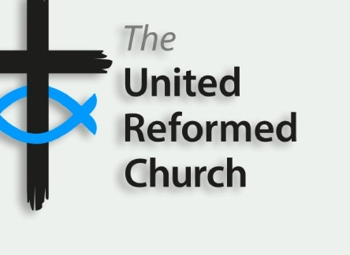
There will still be the Foundation as a face to face course and online (Zoom) course.

The course is available here: Safeguarding Foundation E-Course for phone and tablet (canva.com)

ELDERS
On the 14th of June we held the first online seminar specifically aimed at training Elders in the English churches in their role as trustees. Further sessions are taking place on 5th September at 7.00pm. Please contact Carrie.Kaunda@urc.org.uk to book onto one of these sessions. They will take place on Zoom and last approximately 2 hours. This is vital training to give Elders information about their legal responsibilities in Safeguarding but not part of the mandatory training framework which is detailed in Paper T5 of 2021 Assembly Papers.

DBS VERIFIERS AND SAFER RECRUITMENT TRAINING
Thank you to those verifiers who attended the recent training held on May 16th. This training was provided by Matt Tuckey from DDC and Carrie Kaunda from the Central Safeguarding team at Church House. The training was well received and provided up to date information for those undertaking the verifier’s role in the church. There was also an additional section on Safer Recruitment which looked in detail at how churches can ensure recruitment and supervision of staff supports all areas of safeguarding. This offered an extension to the information provided in the Intermediate Training and is therefore vital for those who have a role in recruiting paid and volunteer staff in their church. The next dates will all take place over zoom, the dates are 10th September 10th October and 15th July. The session lasts just over an hour.
Please contact carrie.kaunda@urc.org.uk to book.

ADVANCED TRAINING
The Advanced Training module is still being revised and will be available to all staff and volunteers later this year.

SYNOD TRAINING
The following dates are available for training:

Foundation
12th September 6.30pm (Thames North Synod/ St Paul’s United Reformed Church)
4th October 6.30pm (Southern Synod Office)
3rd November 6.30pm
13th December 7pm

Intermediate
Tuesday 13th September 6.30pm (Thames North Synod/ St Paul’s United Reformed Church)
Thursday 6th October 6.30pm (Southern Synod Office)
Monday 21st November 6.30pm
Thursday 16th December 7pm

To book on to this training, email safeguarding@urcthamesnorth.org.uk

TRAINING FROM OUTSIDE OF THE URC.
The URC is now recognising training from other denominations. Staff and volunteers in churches who have completed training with another denomination or organisation in the past three years will be required to complete a brief introduction to Safeguarding in the URC rather than the full foundation course. Most staff will then be advised to complete Intermediate training.

GENERAL ASSEMBLY PAPERS 2021
Looking back at Paper T3 Safeguarding Committee from 2021.
Paper T3 saw the passing of resolution 46: that Mission Council’s Safeguarding Advisory Group (SAG) be disbanded and that a Safeguarding Committee be assembled. The final meeting of SAG took place on June 7th and The Safeguarding Committee will begin to meet in September this year.

POSITIONS OF TRUST IN THE FAITH SECTOR
The government is extending the law that prevents adults from engaging in sexual relationships with 16 or 17-year-olds, to include adults who work in religious settings. The Sentencing Council can impose a maximum of 5 years imprisonment for adults who abuse these positions of trust.
The previous legislation, in sections 16 to 19 of the Sexual Offences Act 2003 (The Act) which states it is illegal for an adult in a position of trust to be involved in sexual activity with a person who is 16 or 17 years old previously, excluded faith leaders.
Following numerous high-profile child sexual abuse cases in religious settings, concerns were raised in Parliament and across wider society. The government has therefore decided to create a new Section 22A of the Act in which they will extend positions of trust offences to include where an adult is coaching, teaching, training, supervising, or instructing in a religious context to a 16 or 17-year-old on a regular basis.
For the church, this extension acknowledges that adults who supervise or instruct in this environment are particularly influential over a child’s development, and this includes 16- or 17- year old's who are defined as children for legal purposes. The change in the law recognises that children in religious settings can be subject to manipulation and grooming and aims to reduce this.
It is important to note that an adult will not be in a position of trust where they are participating in the activity with the child infrequently or on one occasion, or where the adult is unaware that they are carrying out the activity regularly in connection with the child.

The United Reformed Church welcomes this development, and we are asking churches to update their policies and procedures to recognise the change.
We would also ask that this message is made clear to those in attendance at your churches to ensure that awareness around this issue is raised. You may wish to consider how you can take steps to ensure that all young people are aware of this and of the ways in which disclosures can be made. Once again, we would like to take this opportunity to ensure that the culture within your church supports those who report any concerns

For more information on the change to the law, please see the government’s Police, Crime, Sentencing and Courts Bill 2021: positions of trust factsheet here, which sets this out in detail. Please note the legislation has also been extended to Sports Coaches.

GUIDANCE FOR ACTIVITIES IN PRIVATE DWELLINGS

It has been normal practice in many churches for some organised church activities to take place in private dwellings (the homes of church people). This guidance is to remind churches of the risks to be aware of and take into account, for the safety of the people who live in the dwelling and for those visiting. Although a manse is normally considered a place of work, for the purposes of this guidance and to ensure good practice, it shall be considered a dwelling.

The guidance can be found here:

Guidance for URC local church activities in private dwellings - United Reformed Church

HOMES FOR UKRAINE
Over 3 million people have had to flee Ukraine and become refugees. There are many ways in which churches, families and individuals can support Ukrainian refugees coming to the UK, from providing accommodation and raising funds to offering a warm welcome and community hospitality to new arrivals. There are also safeguarding considerations to make in order to protect people from harm or abuse. Please see this resource for more information:

https://thirtyoneeight.org/blogs/responding-safely-to-humanitarian-crises/

If you would like further advice or guidance to support a Ukrainian refugee, please contact: safeguarding@urcsouthern.og.uk

