CALLING ALL EMPLOYED AND VOLUNTEER CHILDREN’S WORKERS ASSOCIATED WITH THE UNITED REFORMED CHURCH

Children’s and families’ ministry is invaluable and can be exciting and inspiring, but it can sometimes also be challenging and even lonely.

This is your opportunity to meet together with others in the same role, to be refreshed and equipped, to discover new ideas and resources and to share together in worship and good food, fun and mutual support.

Where?

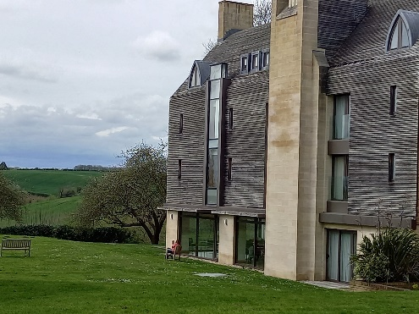The beautiful and secluded Ripon College in Cuddesdon, near Oxford. What nicer place to take a bit of time out?

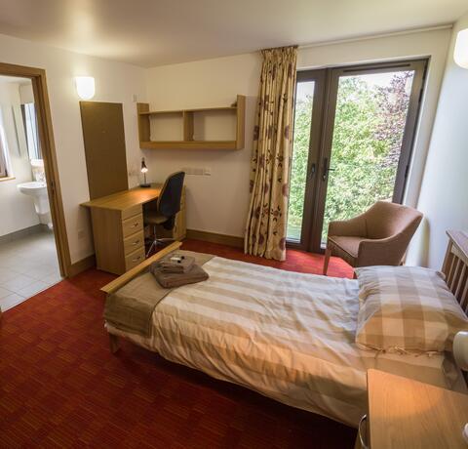

When?

From 5pm (for dinner at 6pm) Friday 1 November to lunchtime Sunday 3 November (Day visitors also welcome)

Cost?

£150 all inclusive (£35 a day for day visitors, with extra £17 for Saturday evening).

**If your church is unable to fund this, please contact Lorraine Downer** [**cydo@urcthamesnorth.org.uk**](mailto:cydo@urcthamesnorth.org.uk)

**Or contact** [**children.youth@urc.org.uk**](mailto:children.youth@urc.org.uk) **for information about the Discipleship Development Fund.**

What can I expect?

Friday:

* Welcome and worship,
* Getting to know you session,
* Late night programme
* Bedtime story

Saturday:

* Worship and Keynote,
* Small group discussions,
* Workshops (choose two from child participation, intergenerational ministry, storytelling, music in ministry),
* Seasonal workshops (choose from marking the seasons of life, outdoor church through the seasons, the Christian calendar, and the difficult seasons of life),
* Family Film Night experience,
* 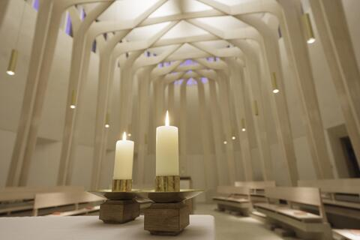Bedtime story.

Sunday:

* Keynote and small groups
* Ask the panel
* Worship (Brick church)
* Lunch and goodbyes

All weekend there will be a bookstall and a marketplace where you can explore a range of different resources.

Keynote speaker: Revd Jenny Mills

*My story began in Twickenham, continued in a small hamlet in Wales (where my Sunday School and family life centred around the ‘Mother Church of non-conformity in Wales’!). When aged 14 I was moved to Surrey (not a great time in my life but a foundational period in my faith life with super Church-family support around me) and then at 18 I went to Northampton to train to be a teacher (and my parents temporarily moved to Iraq!). I became a Primary School teacher and got married and had 2 of my 3 children and went back to Church in my mid-20s and my story developed in ways I could never have imagined! I taught for 21 years and have been in ordained ministry for 16 years. It has been a journey of learning and growing, of changing and being changed and of self-discovery and self-awareness. I now have 3 grown up children and am still married to the man I met whilst at College 1983-87! I have been in the post of Secretary for Education and Learning for the URC and am going into the role of Deputy General Secretary (Discipleship). I look forward to journeying with you, listening, talking, sharing and seeing where this takes us as our stories intertwine and continue.*

BOOK NOW on [**https://bit.ly/URC-children-conference**](https://bit.ly/URC-children-conference)