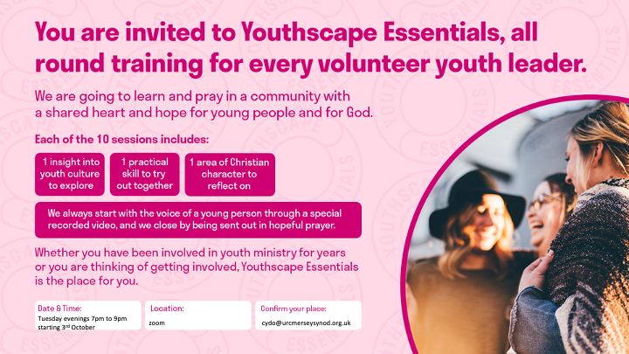**Youthscape Essentials is a ten-week course to equip and strengthen anyone working with/ministering to young people in churches and community projects. Each week the course covers an insight into youth culture, a practical skill, and an area of personal spiritual development. Each session is standalone so you can attend as many or a few as you would like.**

**If you would like more information about the course, find out what will be covered in each session or to order the handbook, click**[**here**](https://urcmerseysynod.us5.list-manage.com/track/click?u=055ad961e3ea77c9829a75f3e&id=a0c7f90ff7&e=6dc0d3d411)**.**

**Every Tuesday night from 10th October to 12th December from 7pm to 9pm on zoom. The course is free to attend but we recommend buying the handbook which can be purchased by Lorraine.**

**cydo@urcthamesnorth.org.uk**