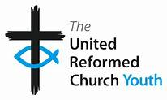
THAMES NORTH & SOUTHERN SYNODS YOUTH RESIDENTIAL
Thursday 30th May – Sunday 2nd June 2024
Join other young people for 4 days of outdoor activities, games, creative workshops, and biblical discussions.

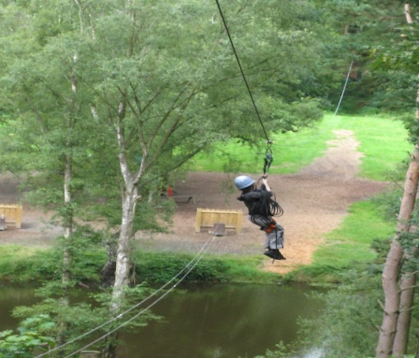
This Photo by Unknown Author is licensed under CC BY-ND

Venue: Whitemoor Lakes Alrewas Staffordshire.
Cost: £65
Age: 11 (must be in Year 7) – 16 years.
Including transport available from London.
Limited spaces available until Friday 3rd May 2024
Register online at: https://bit.ly/residential-2024
Further information: cydo@urcthamesnorth.org.uk

