General Assembly Reports.
Thames North Synod supported 3 under26’s Representatives to experience What Do You Think and General Assembly this year. Christine Ntim age 20, our Youth Representative from Grange Park; Jake Penny age 25 from the American International Church; and Malon John age 19 from Upper Clapton. Please see their reports below.

Within my General Assembly experience, I really enjoyed meeting the under 26 Reps who were all from a variety of synods, I loved making new friends and building on existing relationships. I also thought What Do You Think (WDYT), and General Assembly was very refreshing in a sense that me and the rest of the youth reps could take a step back from our roles and duties and just be a part of the under 26s experience. Everyone in the under 26s were there for the purpose of having a say in the URC and to gain a better understanding of what it means to be a part of this denomination.
Within the structure of the General Assembly, I gained a fascination with the Discussion Section where people would freely come up and talk about resolutions. Overall, I think the discussion section really brought the reality and lived experience into the resolutions and implications it has on people's lives, it was interesting to listen to the discussions.
A resolution that really stood out to me was the resolution on Reform Magazine as I am interested in media and communications especially within the URC. I recently started reading Reform and have seen the essence of it in terms of communicating reaching different audiences, especially the 40+ who prefer print. For the closed session of Reform Magazine, we wholeheartedly agreed to keep Reform Magazine and continue to support in funding. I believe it is important to keep the magazine going with maximum support especially because during WDYT we had a chance to speak with Steve Tomkins (senior editor of Reform) where I got a real insight on their missions to appeal to young people digitally in the future which is something I find significant in Youth today.
Christine Ntim.

Attending General Assembly (GA) has fundamentally changed how I see the URC and my place within it as a young person. The meetings first of young people and some of those who support us within the church and then of the GA as a whole cast a new light on who makes up the URC and what having these conversations between ourselves can do in making better disciples out of all of us and making the URC a more flourishing institution in years to come.
The ‘What Do You Think?’ (WDYT) youth event was something of a surprise to myself. My minister nominated me for GA not knowing which side of 26 I fell, and to go and meet other young people in the URC even knowing that I qualified by only a few months has shifted what I saw at one point as the fate of people my age in church – to be one of very few. I grew up as an atheist and from when I first started attending my local URC as a teenager to now, I have never been in the company of as many young people from the denomination. Following WDYT I know I have a whole group I can turn to if I feel I need that fellowship between us which grew over the days we were there together.
I arrived at WDYT later than everyone else because of a wedding happening the previous day. This means I was not part of all the discussions which were had at WDYT, but I was there to meet the moderator, clerk and those who would be taking their roles in only a few days’ time. As someone who had never attended GA before and didn’t know anyone who was there prior to coming, getting to meet these people who would be sitting at the table in the front under more normal circumstances helped make the whole performance of GA a little easier to understand, and certainly meant that it was less intimidating to talk at the front knowing that we had met many of the people who were up there, although my nerves still got the better of me looking at the large group in front of them. In particular I would also like to highlight the discussion we had as a group with Karen Campbell and Gordan Cowans about the Legacies of Slavery group in the URC. I will leave the discussion of the policy itself to my other Thames North representatives but getting the opportunity to meet them both in that more intimate setting and get the sense that the push by the URC in this way is something that we are leading the way towards reconciliation on really meant a lot to myself and everyone else who was present.
Finally on the GA as a whole, I would like to say that it was an opportunity for groups to meet who might not usually be in the same spaces, and there were both good and bad moments for this through the event. Mealtimes were when I ended up taking part most in discussions. Some conversations were easier than others – the URC contains people with a wide range of views- but they allowed for some deep chats which we could then take back into the hall with us. I think of one meal with a minister who while actively supporting the chaplaincy of trans students in particular felt she was somewhat afraid of talking to young people. I wonder now if there might not be more that could be done to encourage us youth representatives not to cluster quite so much and find more spaces in which we can engage with those who might not feel they have many opportunities to hear our opinions on things. At the same time, it was quite disheartening to know that some attendees had complained about the youth talking among ourselves. Tessa Henry-Robinson made the case for us working things out among ourselves very clearly, but it is still frustrating because this kind of chatter happened throughout the hall. The questions on finance for ministers in particular had people sharing all kinds of stories with those around them of ways this might affect their situation. It feels like more could be done to get these groups better acquainted and to not feel so isolated, sitting as we were at the side on most occasions.
If there were any resolutions which I think should be highlighted, it is those relating to the Gaza Crisis. The discussion of each individual word went on so long that the resolutions ended up featuring on every day of GA. The accompanying paper thoroughly details the situation and makes a useful resource for discussion of the crisis. A real effort had been made prior to GA to have feedback from a number of groups. Ecumenism and interfaith dialogue are central to the issues discussed, and yet it was notable that the breakdown in interfaith dialogue which has occurred as a result of the crisis was not raised more prominently. The URC aims to take a strong position in the Gaza crisis in particular because of strong ecumenical partners in the region. A lack of these in Sudan and the DRC were given as potential reasons why these other conflicts were not raised at all when I asked the team behind these papers later.
The discussion showed the sheer granularity of views on the right position of the URC as an institution on the conflict. It seemed like one thing which would have made the discussion a little clearer would be to have an accepted definition of antisemitism from which to work with. The suggestion that some positions being supported might be antisemitic became quite personal to many members of the GA, and there was an obvious fear of repercussions against those with strong views as the livestream which broadcast the rest of the discussion was turned off when this paper came up each day. I left the GA quite embarrassed by some of the positions of delegates present and the seeming lack of consequences for leaning into conspiratorial thinking about the Jewish people. This was an issue especially for those of us in the youth who had strong feelings about the URC not doing enough having to deal with the suggestion that we would share these conspiratorial, antisemitic views. At an event in which innovation was the core theme, it seemed that we as a church had no means to reject some of these extreme and dangerous points of view outside of the principle that in general consensus we were ‘reading the room’ rather than these individuals. The resolutions increased in scope progressively, and they were thoroughly reworded to meet legal requirements in particular and also the spirit of parity for both sides to an extent. I personally feel like the tendency at GA to focus on nitpicking resolutions for grammatical errors, while important to get right, meant that the discussion become rushed towards the end. The question of whether punishing ‘Israeli registered companies’ in particular was the right position for the church to take was certainly more dividing of opinion than many of the other more general resolutions.
Many of those who spoke in the discussions emphasised the role of individual action in supporting the victims of the crisis. This might be something which churches can choose to be more involved with and thus we may want to consider how the resources included in the paper and the paper itself can be used by churched which are interested.
Jake Penny.
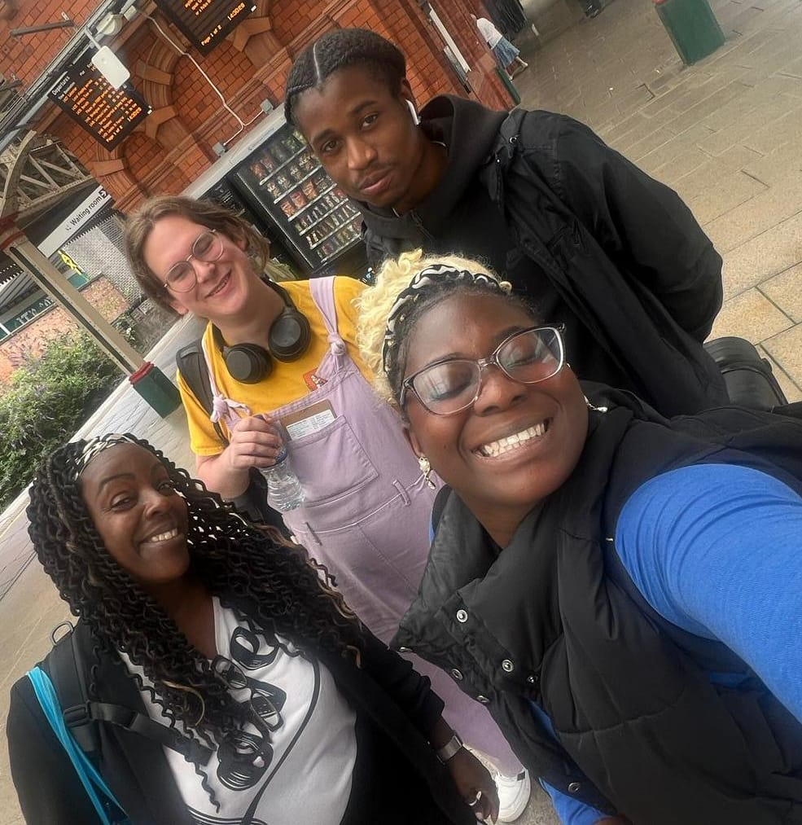
Left to right. Lorraine Downer, Jake Penny, Malon John and Christine Ntim.

